

Program: Post Graduate Diploma (PGD) in Data Science
Course Title: Data Science Project
Course: PGDDS 203
Project Title: Real-Life Project: Recommendation Systems

Submitted by:
Student Name | ID
Md. Sahariar Sahen | 905253005

Submitted to:
Ahmed Imran Kabir,
Assistant Professor
School of Business & Economics (SoBE),
United International University (UIU)
Dhaka, Bangladesh

Table of Contents
1. Introduction 4
2. Dataset and Exploratory Analysis 4
2.1. Dataset Description 4
2.2. Items per Category 5
2.3. Rating Data and Sparsity 5
3. Content-Based Filtering 5
3.1. Method 5
3.2. Content-Based Recommendation Result 6
4. Collaborative Filtering 6
4.1. User-Based Collaborative Filtering 6
4.2. Collaborative Recommendation Result 6
5. SVD-Based Collaborative Filtering 7
6. Evaluation and Model Comparison 7
6.1. RMSE Evaluation 7
6.2. Predicted vs. Actual Ratings 8
7. Content-Based vs. Collaborative Recommendations 8
7.1. Same-User Comparison 9
8. Cold-Start Problem 9
8.1. New-Item Cold Start 9
8.2. New-User Cold Start 10
9. Limitations 10
10. Proposed Improvement: Hybrid Recommendation System 10
11. Overall Model Recommendation 10
12. Business Implication 11
13. Conclusion 11
14. Documentation and GitHub Presentation 11

List of Figures
Figure 1: Items per Category — distribution of 90 products across the six product categories. 5
Figure 2: Predicted vs. Actual Ratings (SVD) actual held-out ratings compared with SVD predictions. 8
Figure 3: Example recommendations — content-based results for a Books item versus collaborative results for the same target user. 9

List of Tables
Table 1: Summary of the Recommendation System Dataset 4
Table 2: Content-Based Recommendation Results for the Selected Item 6
Table 3: Top Three User-Based Collaborative Recommendations Ranked by Recommendation Score 6
Table 4: RMSE Comparison of SVD-Based Collaborative Filtering with the Global Average Baseline 7
Table 5: Comparison of Content-Based and Collaborative Filtering Approaches 9

Introduction
Recommendation systems are data-driven tools that help users discover relevant products or content by learning from item characteristics, user preferences, and patterns in user–item interactions. They are widely used in e-commerce and digital platforms to personalize the information or products presented to individual users. By ranking potentially relevant items, recommendation systems can reduce the effort required for users to find products that match their interests.
In this project, a recommendation system is developed using a synthetic product catalog and user-rating dataset. The analysis explores two complementary recommendation approaches: content-based filtering and collaborative filtering. The content-based approach uses TF-IDF and cosine similarity to identify products with similar textual descriptions, while the collaborative approach uses users' rating patterns to identify similar users and generate recommendations. In addition, Truncated Singular Value Decomposition (SVD) is applied as a matrix-factorization approach for collaborative filtering.
The project aims to examine how these different approaches generate recommendations from the same product catalog and user-rating history. The collaborative models are evaluated using held-out test ratings and RMSE, with a global-average prediction used as a baseline. The analysis also compares the recommendation outputs of the different approaches and examines important practical issues, including the cold-start problem, rating sparsity, limitations of the dataset, and the potential use of a hybrid recommendation system.
Overall, the project provides a practical comparison of recommendation techniques and demonstrates how both item content and user behavior can be used to develop personalized product recommendations.

Dataset and Exploratory Analysis

Dataset Description
The analysis uses the file synthetic_recommendation_system_dataset_1_5x.xlsx, which contains two sheets: Items and Ratings. The Items sheet contains 90 products with item ID, title, category, tags, price, and description. The Ratings sheet contains 5,190 user-item ratings from 450 users, with ratings measured on a 1–5 scale and associated timestamps.
Table 1: Summary of the Recommendation System Dataset
Characteristic | Value
Number of users | 450
Number of items | 90
Number of ratings | 5,190
Number of categories | 6
Average ratings per user | 11.5
Rating scale | 1–5
Overall mean rating | 3.87
Possible user-item combinations | 40,500
Observed ratings | 5,190
Approximate matrix sparsity | 87.19%

Items per Category
The 90 products are evenly distributed among six categories: Electronics, Fashion, Home & Kitchen, Sports & Fitness, Books, and Beauty & Personal Care. Each category contains 15 products. This balanced catalog provides a suitable environment for comparing recommendation approaches without an obvious category-level imbalance.
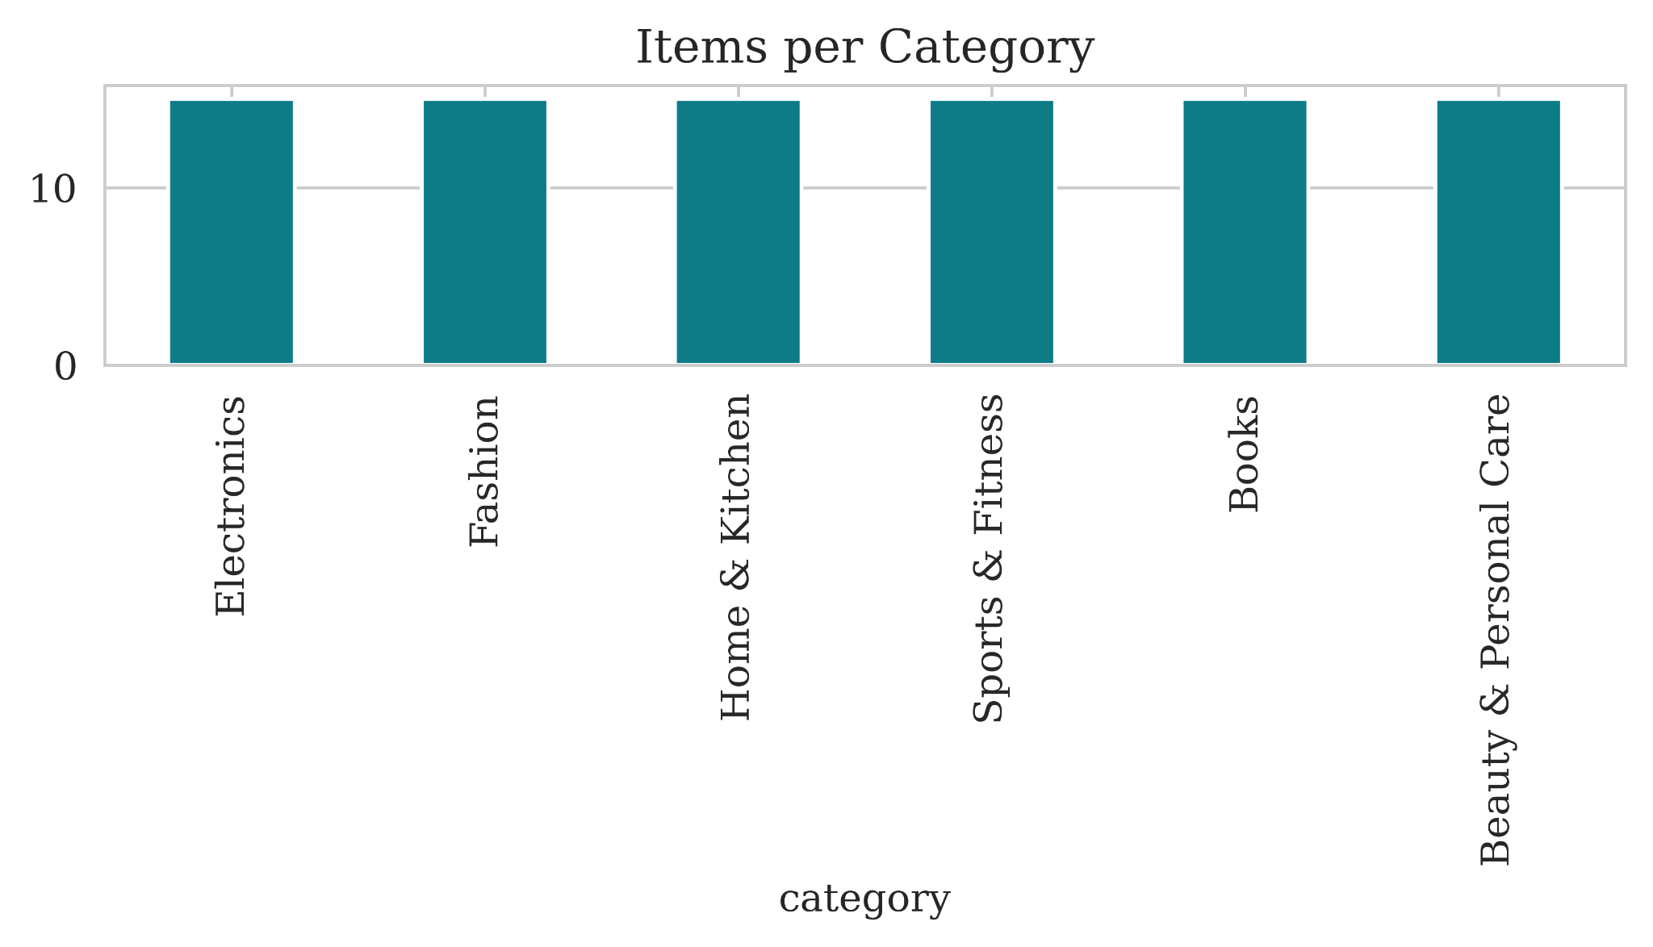
Figure 1: Items per Category — distribution of 90 products across the six product categories.

Rating Data and Sparsity
There are 450 users and 90 items, creating 40,500 possible user-item combinations. Only 5,190 combinations contain observed ratings. Therefore, approximately 87.19% of the user-item matrix is unobserved. This high level of sparsity is important because collaborative filtering depends heavily on user-item interaction data.

Content-Based Filtering

Method
Content-based filtering recommends items that are similar to an item that a user has previously liked or interacted with. In this project, product descriptions were converted into numerical representations using Term Frequency-Inverse Document Frequency (TF-IDF). The resulting TF-IDF matrix had 90 rows and 131 textual features.
Cosine similarity was then calculated between the TF-IDF vectors. A similarity value closer to 1 indicates greater textual similarity between two products. This approach allows the system to recommend products based on their descriptions rather than on the behavior of other users.

Content-Based Recommendation Result
For the qualitative comparison, the first Books item in the dataset was used as the seed item. The three most similar products were all from the Books category.
Table 2: Content-Based Recommendation Results for the Selected Item
Item ID | Title | Category | Similarity
1064 | Illustrated Books Collection 04 | Books | 0.843196
1067 | Beginner Books Collection 07 | Books | 0.736036
1073 | Essential Books Collection 13 | Books | 0.733923

The highest similarity score was 0.843196, indicating strong textual similarity between the selected Books item and Illustrated Books Collection 04. The fact that all three recommendations belong to Books is consistent with the content-based nature of the model.

Collaborative Filtering

User-Based Collaborative Filtering
Collaborative filtering uses user behavior rather than item descriptions. A 450 × 90 user-item rating matrix was constructed, where rows represent users and columns represent products. Missing values were filled with zero only for similarity computation. Cosine similarity was then used to identify users with similar rating patterns.
For each target user, the model selected the 15 most similar users and calculated weighted recommendation scores from their ratings. Items already rated by the target user were removed before ranking the remaining items.

Collaborative Recommendation Result
For target user 5001, the collaborative model produced the following top three recommendations:
Table 3: Top Three User-Based Collaborative Recommendations Ranked by Recommendation Score
Item ID | Title | Category | Recommendation Score
1057 | Performance Sports & Fitness Collection 12 | Sports & Fitness | 1.488013
1070 | Guide Books Collection 10 | Books | 1.196307
1074 | Illustrated Books Collection 14 | Books | 1.042616

These values are weighted collaborative recommendation scores produced by the implemented algorithm. They should not be interpreted as calibrated 1–5 rating predictions. The results include both Books and Sports & Fitness, illustrating that collaborative filtering can identify relationships based on similar users rather than only on product descriptions.

SVD-Based Collaborative Filtering
A second collaborative approach was implemented using Truncated Singular Value Decomposition (SVD). SVD is a matrix-factorization technique that represents users and items through a smaller number of latent factors.
The ratings were divided into 80% training data and 20% test data, producing 1,038 held-out test ratings. The training-set global mean was approximately 3.88. The training matrix was mean-centered so that an unobserved rating was not treated as a true zero rating. The SVD model used 20 latent components, and predicted ratings were clipped to the valid 1–5 range.

Evaluation and Model Comparison
The collaborative models are evaluated using Root Mean Squared Error (RMSE) on the same held-out test ratings. A global-average baseline, which predicts the average training-set rating for every test observation, is used as a reference point. For content-based filtering, where there is no single correct numerical rating to predict, the recommendations are evaluated qualitatively by examining whether the recommended items are consistent with the user's selected item and observed category preferences.
This methodology allows the project to compare recommendation approaches from both item-content and user-behavior perspectives, while also examining how effectively the collaborative models predict unseen ratings.

RMSE Evaluation
Collaborative filtering was evaluated using Root Mean Squared Error (RMSE) on the same held-out test ratings. The RMSE measures the average magnitude of prediction error, with larger errors receiving greater weight.
Table 4: RMSE Comparison of SVD-Based Collaborative Filtering with the Global Average Baseline
Model | RMSE | Test Ratings
Global Average Baseline | 0.986 | 1,038
SVD Collaborative Filtering | 0.999 | 1,038

The SVD model achieved an RMSE of 0.999, whereas always predicting the global average rating achieved an RMSE of 0.986. Therefore, in this particular dataset and implementation, SVD did not improve numerical rating prediction compared with the simple global-average baseline. This result demonstrates that a more complex model does not automatically provide better predictive accuracy.

Predicted vs. Actual Ratings
Figure 2 illustrates the relationship between the actual ratings and the ratings predicted by the SVD-based collaborative filtering model. The dashed diagonal line represents perfect prediction, where the predicted rating equals the actual rating. The predicted values are mainly concentrated within a relatively narrow range of approximately 3.5–4.4, whereas the actual ratings span the full range from 1 to 5.
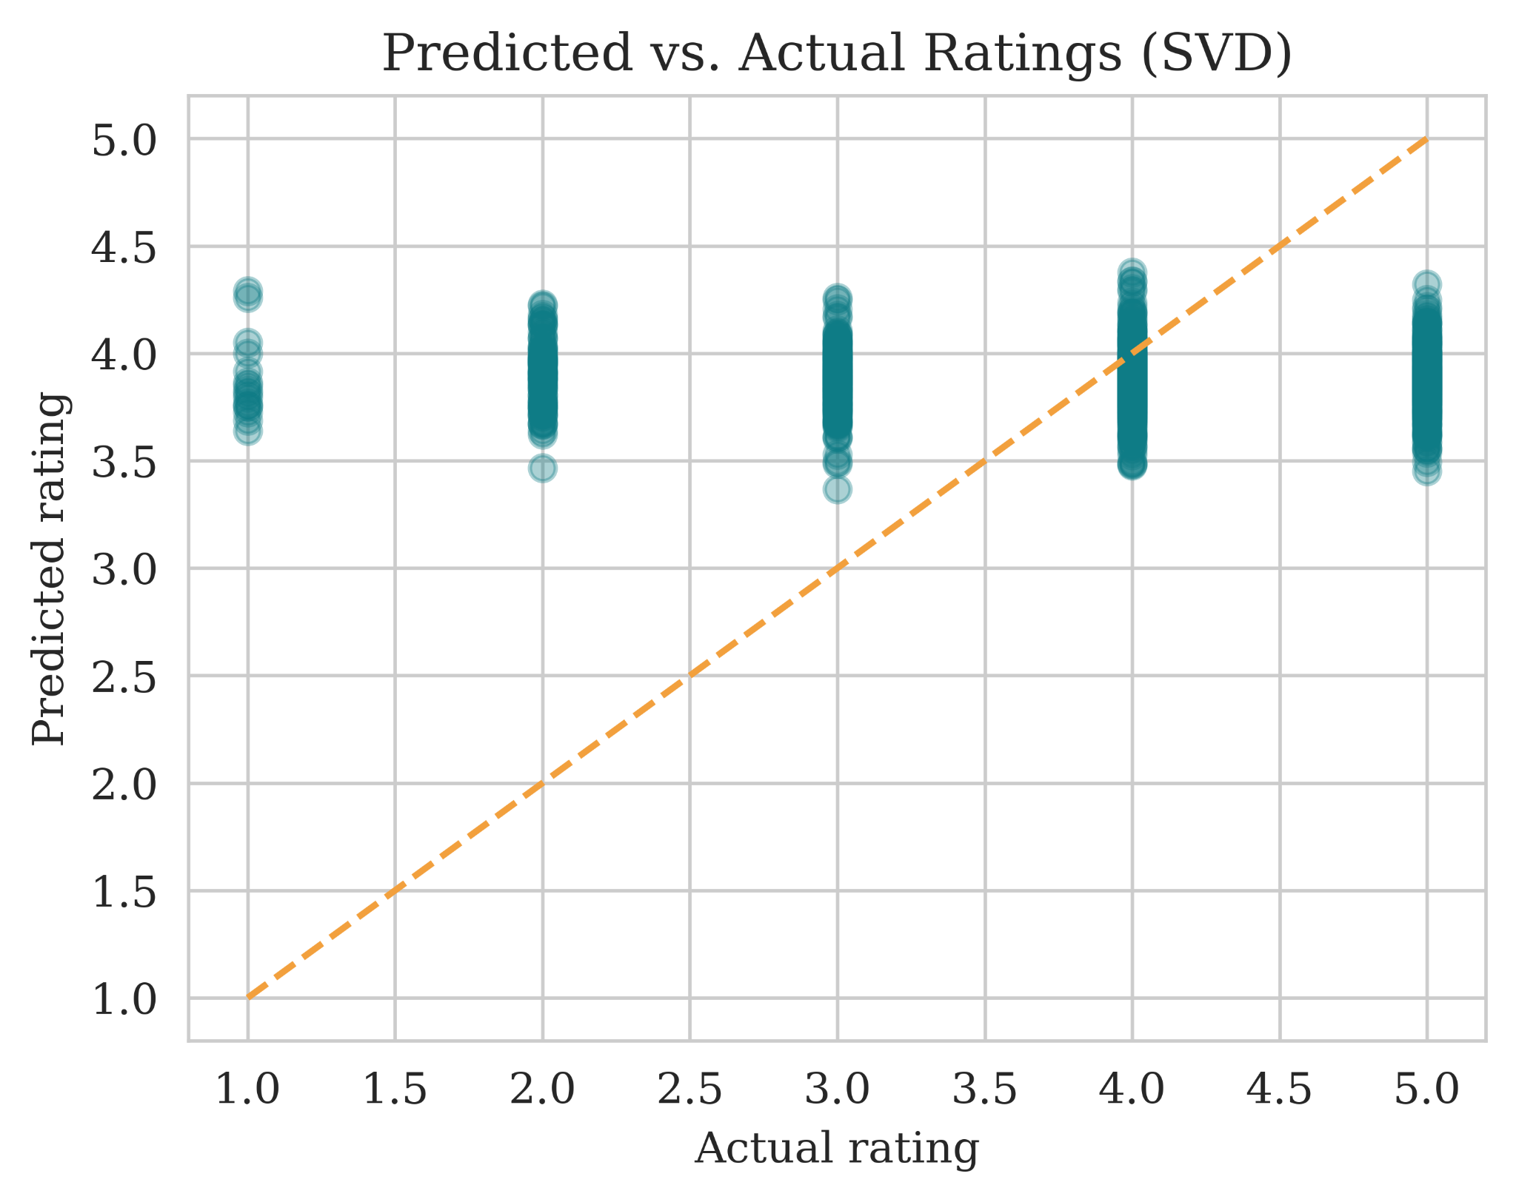
Figure 2: Predicted vs. Actual Ratings (SVD) actual held-out ratings compared with SVD predictions.
The model tends to overpredict low-rated items and underpredict highly rated items, while predictions for ratings around 3–4 show comparatively closer agreement with the actual values. This indicates a clear regression-to-the-mean effect, suggesting that the model captures the overall rating tendency but has limited ability to distinguish between users' strongly negative and strongly positive preferences.
The observed pattern is consistent with the model performance, where the SVD approach achieved an RMSE of 0.999, compared with 0.986 for the global-average baseline. Thus, although SVD captures the general structure of the rating distribution, it did not improve prediction accuracy over the simple baseline for this dataset. The results suggest that incorporating user and item bias terms, optimizing the number of latent factors, or combining rating information with item-content features could improve the model's ability to capture individual preference patterns.

Content-Based vs. Collaborative Recommendations
The two approaches use fundamentally different sources of information. Content-based filtering asks which products are similar to a known item, while collaborative filtering asks which products were preferred by users with similar rating behavior.
Table 5: Comparison of Content-Based and Collaborative Filtering Approaches
Feature | Content-Based | Collaborative
Main information | Item descriptions | User rating patterns
Technique | TF-IDF + cosine similarity | User cosine similarity / SVD
New item | Can recommend if content exists | Needs interaction data
New user | Needs at least one preference | Needs rating history
Recommendation behavior | Usually similar to known items | Can produce cross-category recommendations

Same-User Comparison
For the same comparison, the content-based system used a Books item as the seed item, while the collaborative system generated recommendations for target user 5001. All the content-based recommendations were Books, whereas the collaborative recommendations included Sports & Fitness and Books.
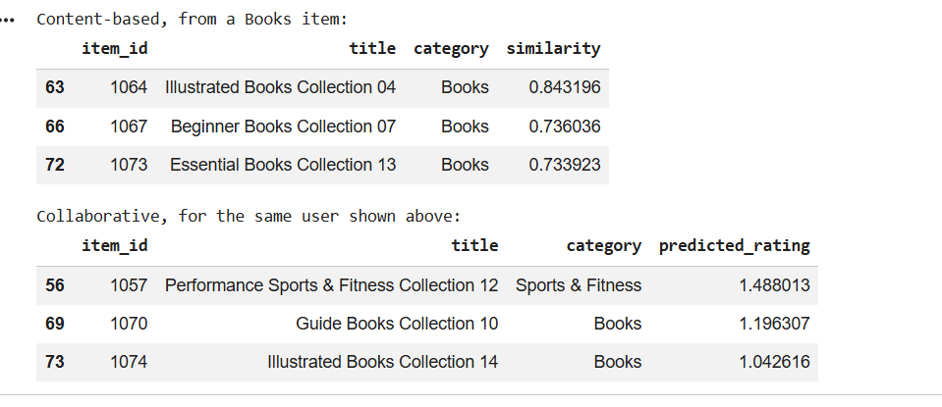
Figure 3: Example recommendations — content-based results for a Books item versus collaborative results for the same target user.
The two approaches therefore differ because they use different information. The content-based system is strongly constrained by the textual characteristics of the seed item. The collaborative system can identify relationships that are not obvious from item descriptions because it learns from patterns shared by users.

Cold-Start Problem

New-Item Cold Start
A completely new product may have no user ratings. Content-based filtering can still recommend the item if its description or tags are available because a TF-IDF representation can be created immediately. Collaborative filtering, in contrast, has no interaction signal for an item with no ratings. Thus, content-based filtering is better suited to the new-item cold-start situation.

New-User Cold Start
A new user with no interaction history is difficult for both approaches. Collaborative filtering cannot identify similar users without rating information. Content-based filtering also needs at least one initial preference, such as a viewed, selected, or rated item, before it can build a meaningful recommendation profile. Once the user provides an initial preference, content-based filtering can immediately recommend similar items.

Limitations
- Synthetic dataset: the data were generated for educational purposes and may not represent real customer behavior.
- Rating sparsity: only 5,190 of 40,500 possible user-item interactions are observed, limiting collaborative information.
- Small catalog: the system contains only 90 products, which is much smaller than a commercial catalog.
- Limited evaluation: RMSE measures rating prediction accuracy but does not directly measure the quality of Top-N ranking.
Future evaluation should include ranking-oriented metrics such as Precision@K, Recall@K, NDCG@K, Mean Average Precision, diversity, novelty, and catalog coverage.

Proposed Improvement: Hybrid Recommendation System
A practical improvement would be to combine content-based and collaborative signals into a hybrid recommendation system. A simple hybrid score can be represented as:
HybridScore = α(ContentScore) + (1 − α)(CollaborativeScore)
Here, α controls the relative contribution of the two recommendation signals. Content information can be used when a product is new, while collaborative information can become increasingly important after sufficient user interaction data are collected. This would combine the complementary strengths of the two approaches and reduce cold-start limitations.

Overall Model Recommendation
For this particular catalog and the results obtained in this project, the content-based approach is the most practical model to use as the current standalone recommender. Its recommendations were coherent with the seed item, it does not require historical ratings for a new item, and the SVD model did not outperform the simple global-average baseline on held-out rating prediction.
This conclusion is specific to the current synthetic dataset and implementation. It does not imply that content-based filtering is universally superior to collaborative filtering. For a larger real-world system, the preferred long-term solution would be to test a hybrid model using ranking metrics and real user interactions.

Business Implication
The results suggest that a company operating an online product catalog should not rely on only one source of recommendation information. Content-based filtering is particularly useful when detailed product information is available and when new products have not yet accumulated ratings. Collaborative filtering can provide more behavior-driven recommendations and may discover cross-category relationships among users.
A practical deployment could therefore begin with content-based recommendations for new products and gradually incorporate collaborative signals as user interactions accumulate. Before deployment, the system should be evaluated using ranking quality, diversity, coverage, and user engagement rather than RMSE alone.

Conclusion
This project developed and compared content-based and collaborative recommendation approaches using a synthetic product-rating dataset containing 90 products, 450 users, and 5,190 ratings. The content-based system used TF-IDF and cosine similarity to identify products with similar descriptions. For the selected Books item, the highest similarity score was 0.843196.
The user-based collaborative model used a 450 × 90 user-item matrix and cosine similarity to identify users with similar rating patterns. Its recommendations included products from both Books and Sports & Fitness, showing how collaborative filtering can produce recommendations that are not limited to the content category of a seed item.
The SVD collaborative model was evaluated on 1,038 held-out ratings and achieved an RMSE of 0.999, compared with 0.986 for the global-average baseline. Therefore, the implemented SVD model did not outperform the baseline for numerical rating prediction on this dataset.
Overall, the findings show that content-based and collaborative filtering provide complementary sources of recommendation information. For the current catalog, content-based filtering is the more practical standalone choice, while a hybrid recommender is the most promising direction for future development. Further work should evaluate Top-N ranking performance using Precision@K, Recall@K, NDCG, diversity, and coverage.

Documentation and GitHub Presentation
The complete project code, dataset, analysis, visualizations, and supporting documentation are available in the GitHub repository. The repository provides all relevant project materials for reviewing and reproducing the recommendation-system analysis.
GitHub Repository: [Insert GitHub Link Here]

